**GatorBall Design Draft**

**Introduction** - project value

* Purpose/Need - Describe the purpose in society for the project you are designing. Specifically, explain why it is needed, by whom, and in what context. Identify how the project is useful and goes beyond a mere demonstration.
  + **This product is intended for football enthusiasts to accurately track first-downs without the need for a referee. It is needed because having a referee step out onto the field to manually measure the football and determine if a first-down has been established greatly slows down the momentum of the game and is also cumbersome to do. Our product will resolve this issue by providing an effortless way of tracking first-downs without the need for any human intervention. This product is primarily intended for small-scale football games like flag football or, potentially, intramural-level games.**
* Augustus - Domain & Prior Art - Explain the field / area of the project and describe existing work in this area. Provide examples from existing commercial products, web searches, or articles appearing in the literature. All examples should be cited. Identify what features will differentiate your solution from others and why your project will make a difference.
  + **Existing work similar to our product is used heavily in the NFL [1]. The NFL embeds RFID tags in player uniforms as well as the football itself. These RFID tags are extremely lightweight and unobtrusive, so they have a negligible impact on gameplay. The data collected by these tags allows the NFL to track statistics such as ball height, position, velocity, as well as player speed, passing rates and much more. These statistics greatly enhance the quality of the game and allow for the NFL as well as football enthusiasts at home to deep-dive into player stats. Our product, on the other hand, will focus specifically on the ball position to allow us to determine if a first-down has been made.**
* Tyler - Impact & Risk Assessment - societal impact (culture, global, economic, environmental and social), ethical context and potential risks
  + **The impacts of this product are limited to within the game of football, which is nonetheless an important institution in our local culture. By eliminating manual measurements in the game it becomes more efficient and quicker to run. This may have the effect of making the game easier to watch and therefore more popular, changing its role in our culture. By saving on the labour costs of taking these measurements, football leagues will benefit economically, although this comes at the cost of the jobs lost due to the technology. Some football fans might also consider the use of the technology inauthentic to the game; such a cultural impact to the sport itself might not be assessable without having to introduce the technology.**

**Joshua - Statement of Work** - work to be done during semester

Milestones -

* Semester 1: Design revision (Week 8), Pre-Alpha build (Week 10/11), Design Prototype (Week 13/14), Design Prototype Presentation (Week 14/15)
* Semester 2: Alpha Build and Test Plan (Week 3), Beta Build and Test Plans, Alpha Results (Week 6), Progress Presentation (Week 7), Preliminary Report and Release Candidate (Week 10), Final Report and Production Release(Week 13), Final Presentation (Week 14/15)

Core Features-

* Microprocessor or active RFID within the football to gather and relay positional data
* Location relays using microprocessors located within/on the first down markers and pylons to provide better positional data using active RFID and Bluetooth systems
* User facing application to display data and show location of spot for the football
* Communication protocols over Bluetooth for user data transmission and RFID in order to gather positional data
* Positional data accurate to within <10 cm to ensure proper spots.
* Fast accurate triangulation of location.

Secondary Features-

* Positional data accurate to within <3 cm ideally for accurate placement and use within professional settings
* 2 anchors within each end zone to reduce costs and computation
* If using a microprocessor application within footballs, potential to gather other data such as speed, rotation and other forces the football experiences through play.
* Error detection for wireless communication

Design Revision - Improve on our product roadmap and further research and revision towards planning our project.

Pre-Alpha Build - Provide a clear foundation for the products infrastructure and architecture, research, design and experimentation on potential solutions to ensure communication between the microprocessor, location relays for collection of positional data and user devices to show the data they need.

Design Prototype - Demonstrate the core features and feasibility of our product, namely communication between microprocessor and locational relays to be able to show position of the football.

Prototype Presentation - Outline current status and future goals of the project moving into semester 2. Including a prototype demonstration and deliverable plan to complete final deliverable.

**Deliverable Artifact**s - what will be delivered at the end of the project? Hardware, software, and documentation

* A short description of the artifact – how does it fit into the project as a whole?
  + **At the end of the project, our team will deliver a package composed of a few different artifacts. The hardware we will deliver at the end of the project will be a microprocessor that continuously collects positional data (and potentially velocity and rotational inertia) from a RFID tag. The software we will deliver will include the code we use to accomplish this. Finally, we will deliver user-friendly documentation that outlines how to set up and use the product.**
* For software/documentation, dissemination plan: format and distribution of project
* Joshua | Accessibility/Usability/Maintenance Plan - how will the project remain useful long term?

**Mockups** - visual models; wireframes, draft schematics, and other diagrams

* Interfaces - parts of project with human interaction | Ricardo
  + Physical/Graphical Interface - The live location of the football will be displayed on a computer screen via some web based interface. On this interface, the user will be able to see a 2D representation of a football field along with the football’s current location, the line of scrimmage (highlighted red), and the first down line (highlighted yellow). Additional information such as yardage-to-gain, play clock, game clock, etc. will also be displayed on the screen.
  + Outside of displaying data, would there be any need for interaction for the following interface?^^^
  + Need to create a sketch/diagram of possible display screen
  + Programming Interface - There will be 4 Decawave 3000s present in our design: two acting as anchor points in each end zone, one within the football, and one connected to a central processing system located near half-field. These four modules will communicate via ultra wideband signals to triangulate and track the location of the football during the game. The module part of the central processing system will be connected to the **PROCESSOR** with SPI and relay the current location of the football. Lastly, the processor will be connected to an output device (laptop, CPU, mobile, etc.) where the data will be displayed, stored, and manipulated.
  + Still need to write specification about calls and/or protocols and diagrams
* Tyler - Systems - how systems communicate with each other (hardware and software)
* Augustus - Networking - any type of telecommunication; application

* Storyboards - mockup of each software screen | Ricardo
  + Heavily diagram/visually based
  + Mock data display screen
* Andrew - Draft Schematics - draft model for schematics; major components, what they do and how they connect

Below are pictures of the DW3000 and a nRF52 that will be located on a PCB inside the football. The DW3000 will take the information from the anchor points and send the data through SPI to the nRF52 microcontroller which will do the calculations and send data to the computer program to the referee. Pins 5-8 on the DW3000 are general I/O pins so we will use those and the same thing for the nRF52 pins P0.03 to P0.06 are general purpose I/O pins. So we will connect Pin 5 to P0.03 for MOSI, Pin 6 to P0.04 for MISO, Pin 7 to P0.05 for the SCK and Pin 8 to P0.06 for the SS. The nRF52 will control the clock and the select line and these configurations will allow us to communicate the DW3000 with the nRF52.

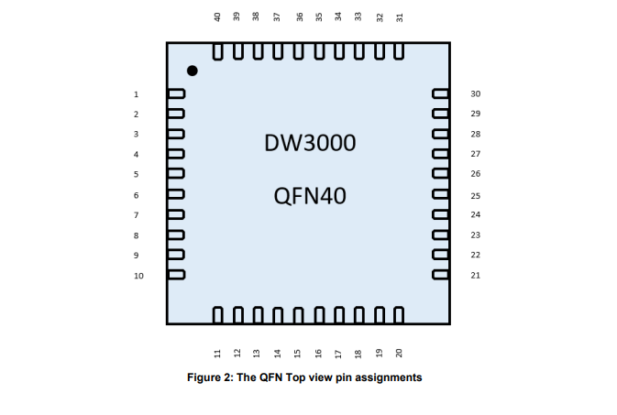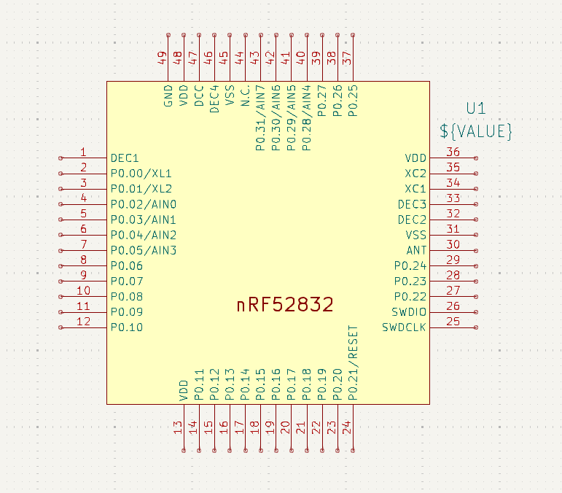

**Sources:**

**[1]** [**https://www.engineering.com/the-technology-behind-the-nfls-incredibly-precise-stats/**](https://www.engineering.com/the-technology-behind-the-nfls-incredibly-precise-stats/)

**Final design (for now):**

**2x** [**https://www.makerfabs.com/esp32-uwb-dw3000.html**](https://www.makerfabs.com/esp32-uwb-dw3000.html) **[anchors]**

**1x** [**https://www.qorvo.com/products/p/DWM3000**](https://www.qorvo.com/products/p/DWM3000) **[transponder], we will fit this on to a custom PCB to minimize footprint of physical component inside football since we don’t need a lot of the features from the microcontroller linked above.**